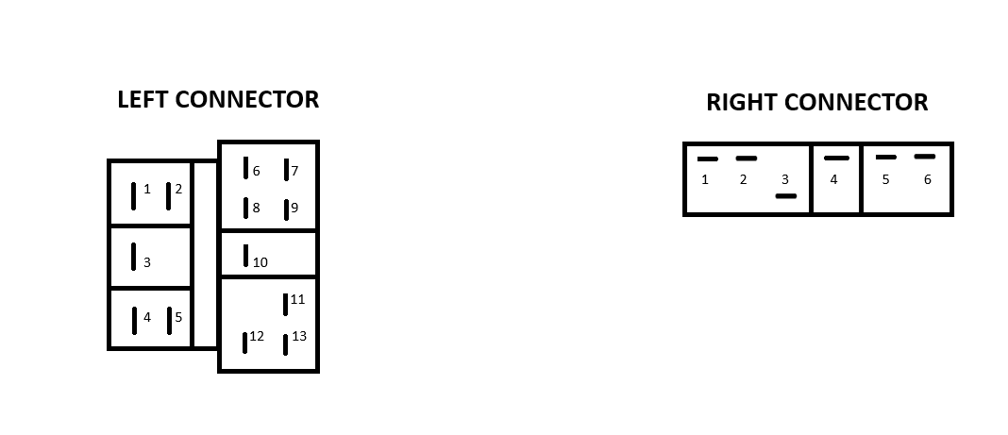**Pinout for Valeo 61557114 (Citroen Steering Column Stalk Switch)** 96 203 765 80

**LEFT CONNECTOR PINOUT**

|  |  |  |
| --- | --- | --- |
| PIN IN | PIN OUT | ACTION |
| Pin 3 | Pin 4 | Normal lights |
| Pin 2 | Pin 5 | Horn button |
| Pin 13 | Pin 11 | Blinker left light |
| Pin 13 | Pin 9 | Blinker right light |
| Pin 12 | Pin 6 | Fog lights |
| Pin 12 | Pin 1 | Main/dipped beam headlights |
| Pin 7 | Pin 10 | Main beam flash |

**RIGHT CONNECTOR PINOUT**

|  |  |  |
| --- | --- | --- |
| PIN IN | PIN OUT | ACTION |
| Pin 2 | Pin 3 | Wiper level 0 or 1 (off when spraying wiper fluid) |
| Pin 4 | Pin 6 | Wiper level 1 |
| Pin 4 | Pin 2 | Wiper level 2 (same pins as single wipe) |
| Pin 4 | Pin 1 | Wiper level 3 |
| Pin 4 | Pin 2 | Single wipe (same pins as wiper level 2) |
| Pin 4 | Pin 5 | Spray wiper fluid |